**

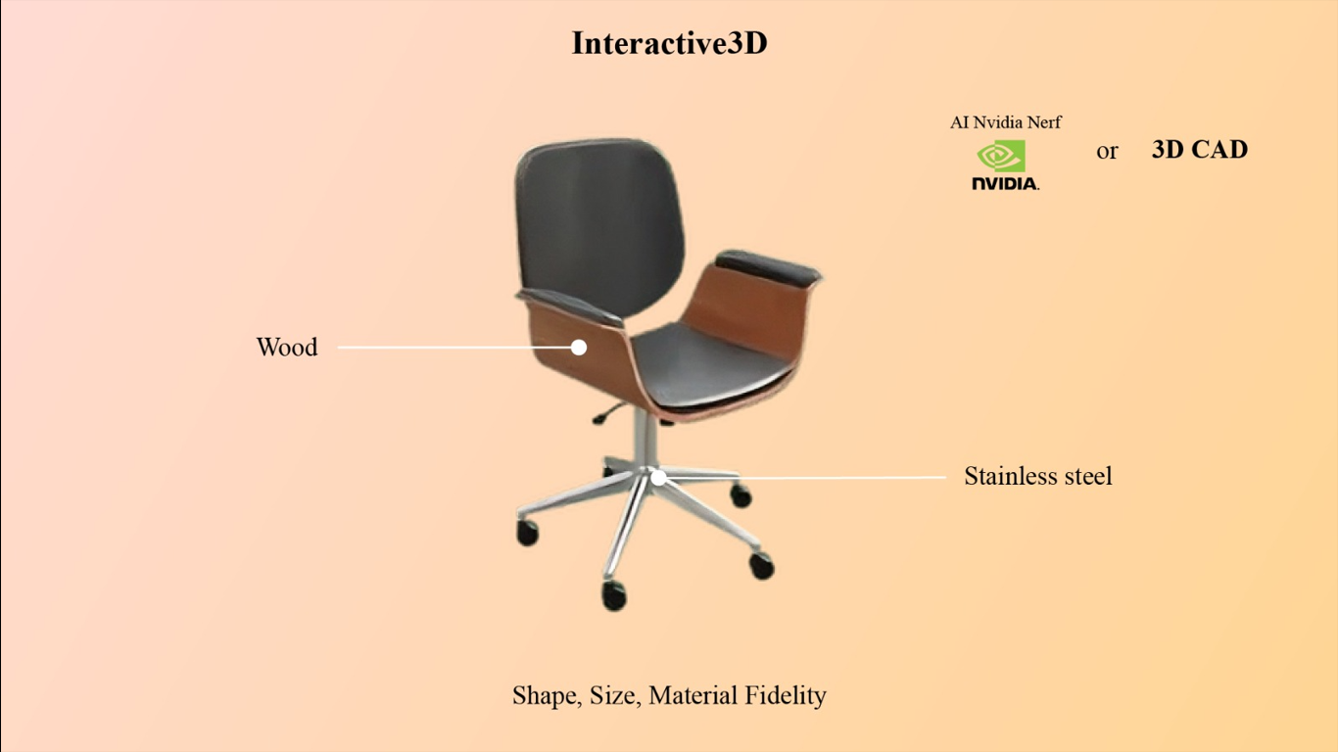

**Subject: Revolutionize Product Exploration with VisCommerce's Interactive 3D Room Planner**

Dear [Recipient's Name],

I trust this email finds you well. I'm thrilled to introduce you to the groundbreaking capabilities of VisCommerce's 3D Room Planner, which leverages cutting-edge technologies to redefine how we present products in an interactive 3D environment.

With a focus on shape, size, and material fidelity, this tool is poised to elevate our product exploration experience, enabling us to showcase even the finest details in unparalleled realism.

In the dynamic landscape of e-commerce, providing customers with a comprehensive understanding of our products is paramount. VisCommerce's 3D Room Planner utilizes state-of-the-art technologies such as AI, NVIDIA NeRF, and 3D CAD to offer an immersive experience that goes beyond traditional imagery.

**Here's a glimpse of the transformative power these technologies bring to our presentations:**

* **Shape Fidelity:** Using advanced AI and 3D CAD, the 3D Room Planner allows us to faithfully represent the shape and form of our products. Customers can interact with items and explore their contours, angles, and dimensions in ways that static images simply can't convey.
* **Size Exploration:** With the tool's interactive 3D interface, customers can gauge the size of products more accurately. They can virtually place items within their intended spaces, ensuring a perfect fit and preventing any sizing misunderstandings.
* **Material Realism:** By integrating material fidelity technology, our products appear as they would in real life. Customers can scrutinize textures, finishes, and material details, giving them confidence in their purchase decisions.
* **NVIDIA NeRF Enhancement:** The utilization of NVIDIA NeRF (Neural Radiance Fields) technology allows for highly realistic renderings. The interplay of light and shape is accurately represented, producing images that are closer to a photograph than traditional 3D renderings.
* **Inclusive Exploration:** The interactive 3D Room Planner is user-friendly and accessible to a wide range of users, even those without prior experience with 3D tools. This inclusivity ensures that our customers can fully engage with our products, regardless of their technical background.
* **Enhanced Realism:** By combining these technologies, the tool provides an unprecedented level of realism. This is crucial in today's market, where customers expect to have an immersive and authentic online shopping experience.

The potential of VisCommerce's Interactive 3D Room Planner is awe-inspiring. By embracing AI, NVIDIA NeRF, and 3D CAD, we're not only showcasing products but creating an environment where customers can virtually interact with them.

This fosters a deeper understanding and connection, paving the way for more confident purchasing decisions.

Should you wish to explore these technologies further, I'd be delighted to offer additional insights or arrange a demonstration.

The VisCommerce 3D Room Planner truly represents the future of product presentation, and I'm excited to see how it transforms our customer interactions.

Thank you for your time, and I'm eager to hear your thoughts.

Best regards,